Gitae Bae baegy002(110310861)

Course | Operating Systems & Toolchains (COMP 2035)
Name | Gitae Bae
Email | baegy002@mymail.unisa.edu.au
Identifier | 110310861
Date | Sunday, 24/04/2022

Team: 03_Tuesday_14_Group 1
Including Gitae Bae, Haozhuo Zheng, Callum Sproul

- Project Overview

First of all, our group1 timeblock application as a countdown timer is concentrated about simple to see and easy to use. That is why application users can use a lot of functions and uncomplicated to work it. Secondly, our timeblock background colour is sky blue and the button colour is white. Therefore, users can feel comfortable and can find peace of mind. Not only it is easy to utilize for all users, but it can make you feel better just looking at it. Secondly, the main feature of this application, the app allowed users can write a to-do list and start the timer and then the user can pause and continue the time and extend one minute and skip the current task and delete the task. Also, the User can Export time and to-do in the CSV and import possible and this project contains the bug tracking and version control from the GitLab.

2. Timeblock for online meeting

We made the countdown timer using Python Tkinter, and First, I created a class timeblock, under which I created a basic draft init using self, and then created a countDown method to set a basic timer. Next, defined the addTask method so that you can register what to do like a to-do list. After that, we made pauseTimer,
continueTimer, and extend methods and you can use the timer
Gitae Bae baegy002(110310861)

freely by registering the pause, continue, and extend buttons. If

present, it will allow you to handle the following actions. Also, there is an advance method If the current job is running and there are other jobs, it will process the next job. After that, the task can be deleted through the deleteTask method, and files can be downloaded and exported through import and export.

3. Individual Contribution

Details of contribution in Features Version1
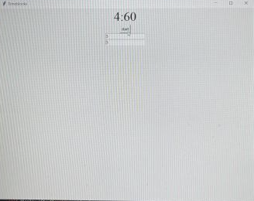
For the version1 make the Timer and Subtask, we discussed how we make the timeblocks and we made a sketch of the draft. Also, Our team member who is Haozhuo Zheng is good at Python, so we started making it with Haozhuo Zheng. He almost made feature1 by himself and I and Callum Sproul gave some help and sources.

Gitae Bae baegy002(110310861)

Details of contribution in Features Version2
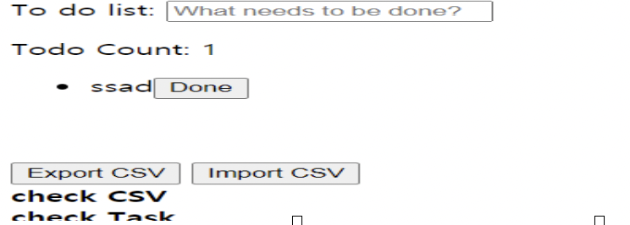
For this part, our team members Haozhuo Zheng and Callum Sproul work on it. For version2 we put the function called CSV Import and Export.

Details of my contribution in Features Version3

I made the pause, continue and extend buttons and also made to be able to work correctly and fixed some details of the buttons. Also, Callum Sproul made a CSV file and Haozhuo Zheng fixed all

Gitae Bae baegy002(110310861)

of these timeblcks. In this one we make people can be easier to see all the features and makes them clear.

Sometimes people don't realize how precious their time is, and they just waste too much time. When we take a break, we do too much and spend a lot of time outside. To save it and use our time more efficiently, we need something systematic, which is why we create this function for that. So after I'm done with all the work, I'll contribute this feature and save you a little more time. If you have a set time for everything you do, you will be able to use your time well. To collaborate with other group members, we always meet in the University library or sometimes we need to work, so also, we used to phone call. And we also used to issue in GitLab for the bug tracking.

4. Software workflow process and software development environment

For the workflow, our team uses to waterfall method. And also step by step all the work. Firstly, we analyze Software requirements and then we try to Design what we want, and which way is more impactable to make a time block app. Then we Implementation to Python and do the Test. And check the code and make the Maintenance development cycle by git lab commit. The benefits of our development environment are easy to find results and we do not need to use too much complicated code. When developing an application, it was used to solve the problem of prolonged development time due to application design, and it was created for responsive applications suitable for mobile environments.

